**Introduction/Problem Statement**

Picture this: you’re a language learner who’s braved a year of coursework and a top ranked Duolingo player. You’re excited to go abroad to practice with native speakers, and it’s the night before your big flight. However, you have 1 big fear… you’ve never practiced with a native speaker before! As your sleep takes hold, you catch a glimpse of Duo’s owly shadow over your bed as the world fades to black…

There are a variety of ways to learn a foreign language. Common resources include textbooks, coursework, or online tutoring. Other online tools, such as Duolingo, aim to motivate education through gamification. Our research interest for CS239: Human Computer Interaction is to identify the top challenges that language learners face in order to potentially provide a tool that can drive language learning.

To do this, we’re following a design process common in the HCI (Human Computer Interaction) space. First, we conduct user research to figure out what our potential users are like and what issues they’re facing through interviews and surveys. We can then take these results to figure out common personas and scenarios and a solution that will help them.

For those who don’t know what personas and scenarios are…

## Personas

What are personas? Personas are a way to represent a target user base by creating a person that best summarizes the users it represents. They are effective in summarizing the user base into common areas in order to identify any challenges or concerns when walking through scenarios.

## Scenarios

Scenarios are exciting! Essentially, they’re a way to set a scene in order to bring a persona to life. They should aim to describe what a persona would feel and react to a certain setting, and explore what senses (pleasant or unpleasant) that they would experience.

From our understanding of the language learning space, we hypothesized that motivation was a key challenge to learn languages effectively. We also felt that existing tools and apps do not allow for language learners to easily access conversational topics that are niche to each person’s interests. Going into the user research period, we get to see whether or not our initial beliefs will hold, or if we will learn new things from our user base!

# Methodology

For the user research, our team used two approaches, which are interviews and surveys. These two methods make it easier for us to gather responses and reach out to target users (such as friends, family members, and classmates who have the language learning experience). It can also help us to gather more personal language learning stories while capturing broader trends across a wider range of users.

**Interviews**

We conducted about 10 interviews with individuals who have experienced challenges on the journey of learning a second or third language. These interview sessions last between 30 minutes to an hour, and were structured to discover each interviewee’s learning process, the motivation for them to learn another language, and the tools they used to learn the language, their feedback and opinions about these tools, as well as the challenges they faced. These collected personal narratives helped us to get more information about the real-world applications and limitations of existing language learning tools.

**Surveys**

Our surveys contained a similar set of questions but were structured to allow for more concise responses, catering to those unable to commit to longer interview sessions. The survey, taking about 10 minutes to complete, mainly focused on the general language learning process, motivations, challenges, and so on. We collected about 35 survey responses, and through the survey results, we were able to capture a panoramic view of language learning strategies, get to know diverse opinions about existing language learning tools and more stories from our survey respondents.

# Findings

From our user interviews and surveys, we found that the most prevalent challenges to learning a new language were:

1. Memorization of vocabulary
   1. especially when the language has a foreign writing system, memorizing vocabulary is difficult for many learners
2. Commitment/Consistency
   1. Due to lack of opportunities to practice and not enough dedicated time to resources, even with apps that claim to take <15 minutes a day, people struggle with consistent learning
3. Learning engagement mismatch
   1. Many people felt that they didn’t have access to resources that could match their level easily. For example, one user reported Duolingo was too easy/not engaging enough for them, but simple conversations with native speakers was still a daunting task

We also researched existing resources in the language learning space, and heard feedback from users who’ve used these tools for learning. We compiled these tools into a common design space in order to better understand what tools are available for language learning:  
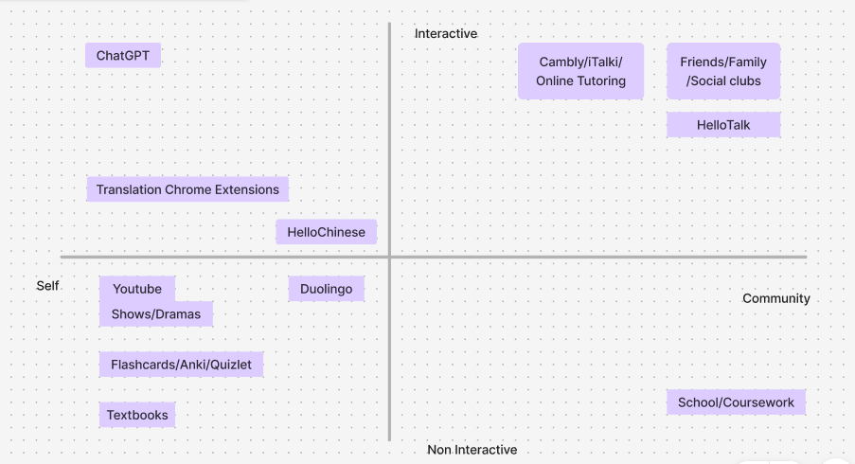

Figure 1. This design space has one axis ranging from self to community. The other axis measures the interactivity of each tool, with rote memorization/reading being the least interactive setting.

By understanding the common challenges that users faced, we were able to split our user group into 2 main personas, broadly summarized as heritage vs non heritage speakers. We decided to walk through a scenario where each person is visiting a country that speaks their language of interest in order to better convey the problems they may face.

The first type of people that we identified are heritage speakers. These are people who learn the language from speaking with family or their community, but do not necessarily have a formal education in reading and writing with their language. They may be motivated to learn their language in order to continue communication with their family. When abroad, they can converse with natives, but they may struggle with official documentation, road signs, and other forms of communication that involve reading and writing. Many heritage speakers also report a decrease in fluency after spending too much time away from home, such as when in college or working full time.

The second type of people we identified are those who learn a language out of interest. The end goal for these users is usually to converse with natives of the language, or be able to understand the language in popular media. This person may not have immediate access to a native speaker like a heritage speaker would, and thus the listening and speaking modalities are typically weaker than reading and writing. Typically, they would be learning languages from the tools that they are aware of, such as taking courses, participating in online tutoring, or self studying with textbooks and language learning apps. When it comes down to practicing with native speakers abroad, they may feel embarrassment or a lack of confidence due to limited exposure to conversational topics, as well as limited exposure to the pace of native speakers’ conversation.

After identifying personas and a common scenario, let’s dive into a proposed solution with a storyboard!

# Who are we trying to help!

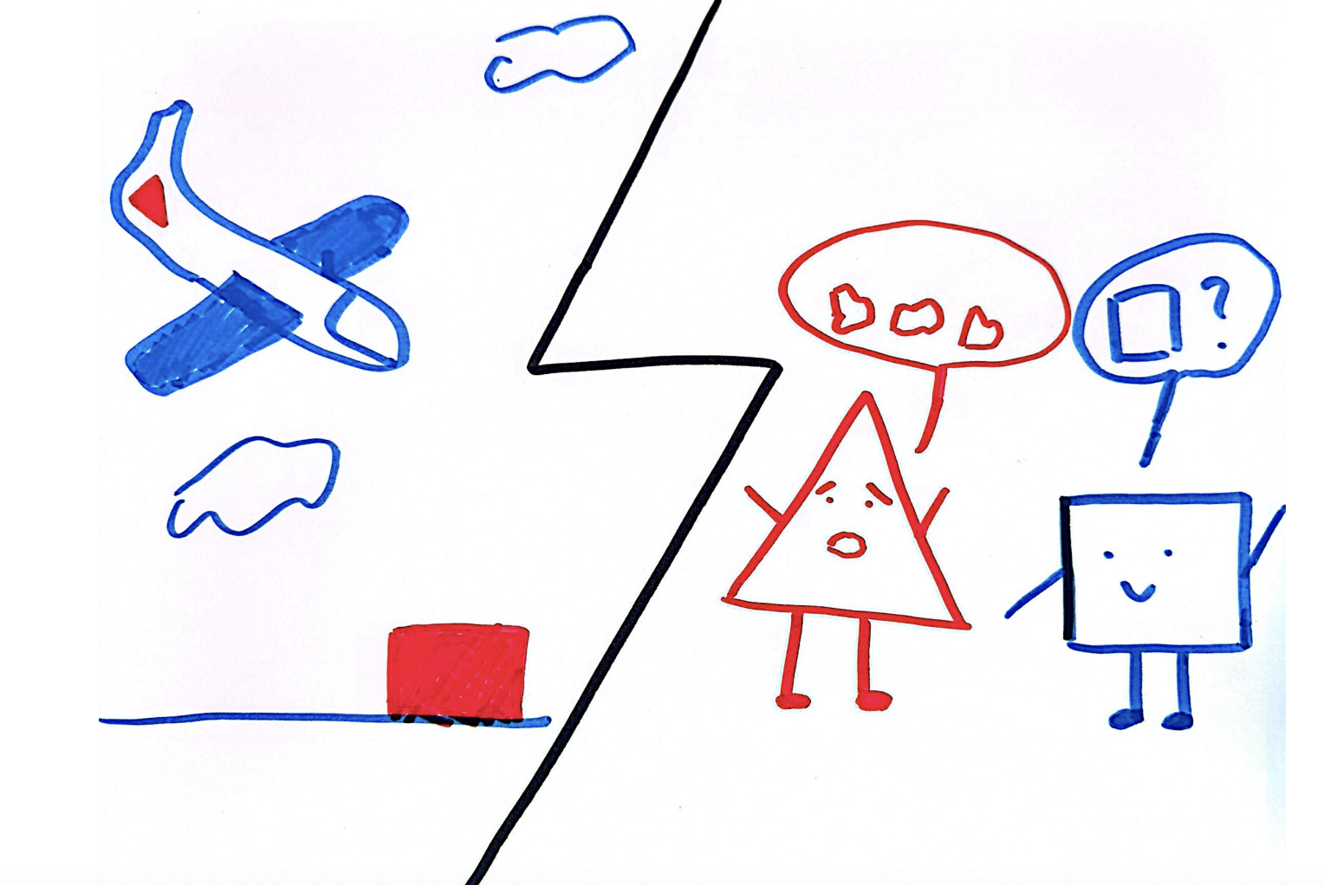

**Non Native speakers**

The first persona are beginner or intermediate learners that are learning languages out of interest or for fun. These learners are typically not exposed to native speakers on a regular basis, and want to learn in order to converse with natives. However, when they travel abroad to a new country, they may experience a mismatch between their perceived skill from reading and writing and their conversational skills. They may also feel a lack of confidence in their ability to converse due to limited exposure.

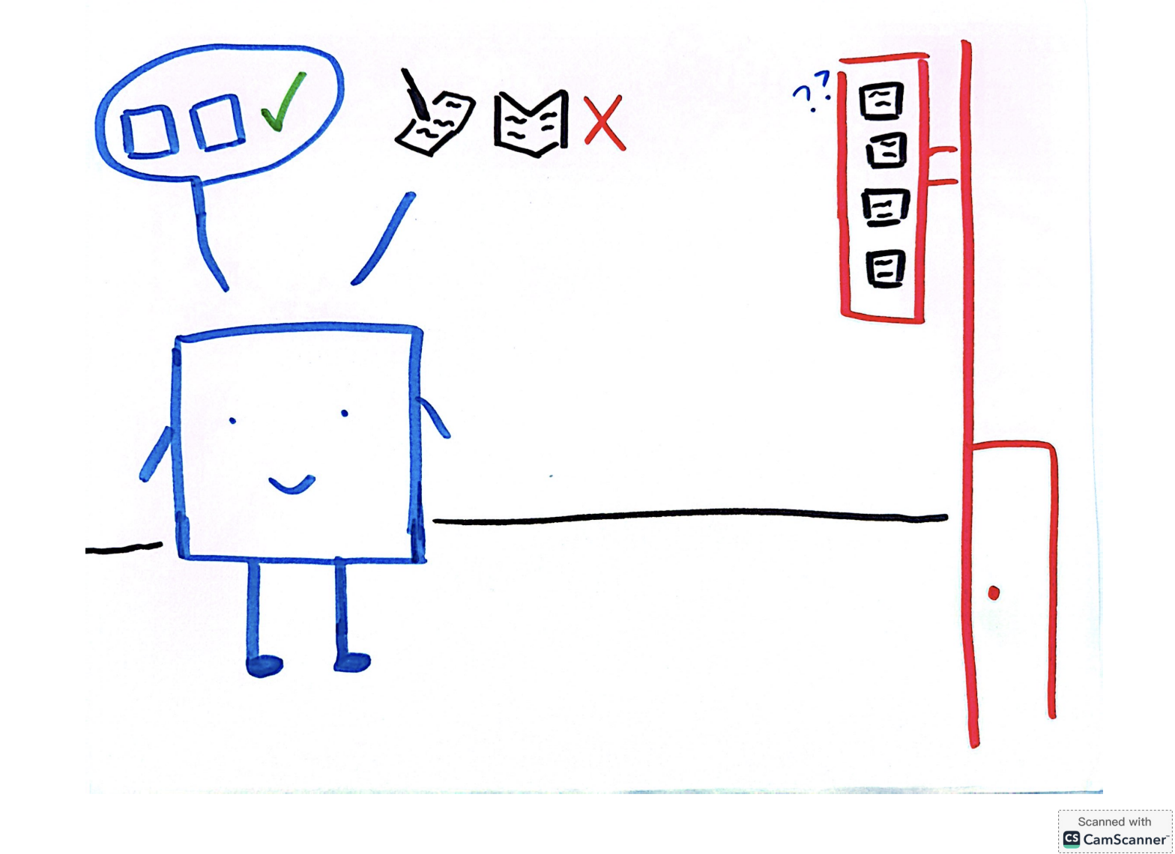

**Heritage speakers**

Heritage speakers have strong speaking and listening skills, but often struggle with reading and writing.

# Once upon a time…

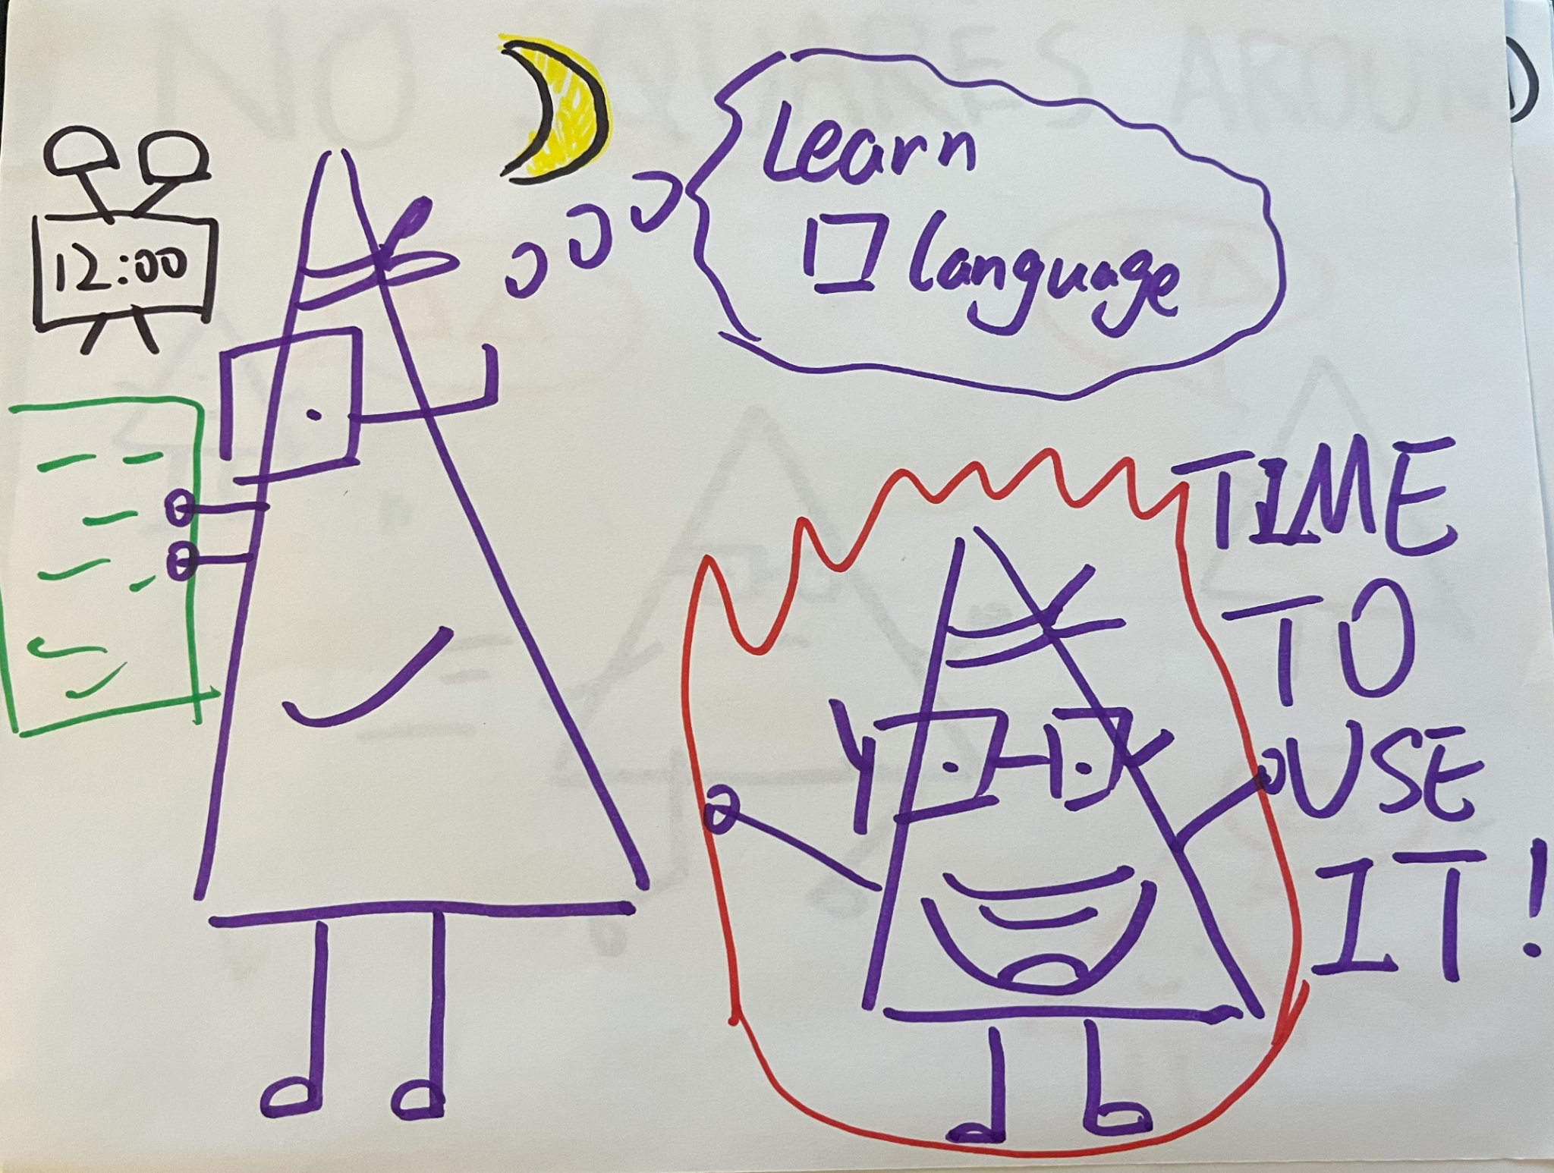

**Big T**

Big T, our beloved triangle, is a non native speaker who really wants to learn the square language! He spent a lot of time studying on his own through textbooks and online media, and is excited for the chance to practice conversation.

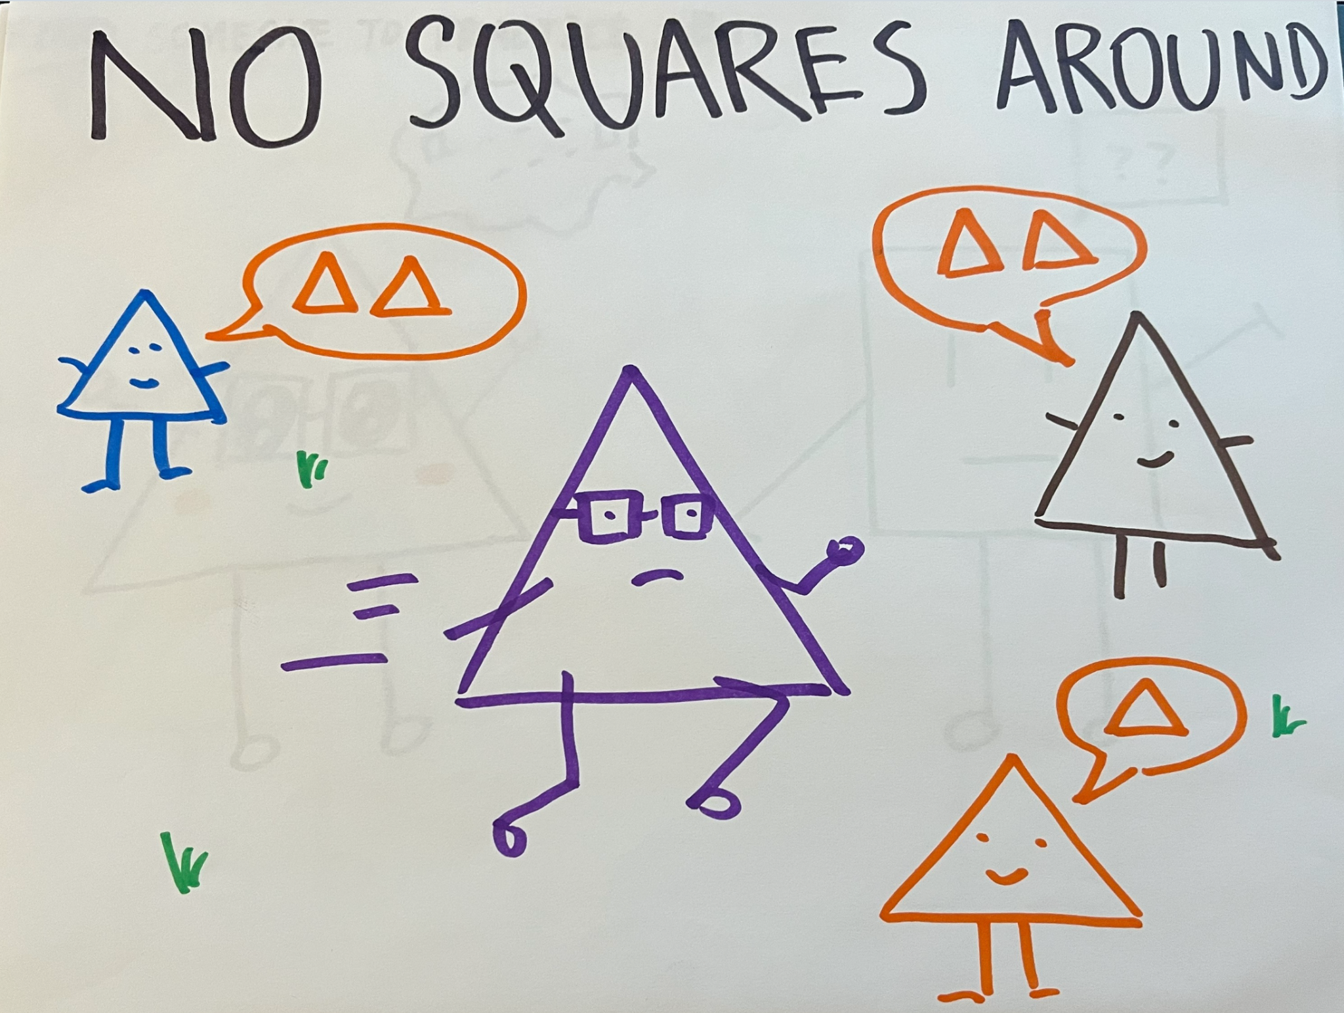

**No practice partners?**

Big T is looking forward to practicing, but since he lives in TriangleLand, he can’t find many squares around to practice with.

# 

**Big T finds a Square! But…**

Big T finally met a square at long last! However, in his excitement he also realized that he doesn’t really know how to carry a conversation with interesting topics. He had a lot in mind but his vocabulary and comprehension isn’t quite there, and the square has a hard time understanding him :( His confidence in his speaking isn’t quite there yet…

# Problem statement

There are two problems we want to solve!

After our interviews and surveying, we ended up with two different problem statements: one for the heritage speakers (people who grew up in a family that spoke a different language) and non-heritage speakers (those people who are starting from zero).

**Heritage Speakers:**

As it turns out, growing up surrounded by people who speak a secondary language (and who may or may not expect you to also respond to them in that language) generally makes it easy for you to, you know, speak and listen in that specific language. Unfortunately, that same level of skill really didn’t translate into reading and writing, probably since people didn’t really send letters or text messages to family members as they were growing up.

Also, once these speakers get out of the house and away from their family (like in high school and especially college), that usually means less exposure to that language. Less exposure means less practice, and less practice means being more likely to forget how to stay proficient in that language. So now, we have quite a few speakers who, through exposure, did well speaking and listening to a language, but have gradually lost that ability through a lack of practice and exposure.

**Non Heritage Speakers:**

Unlike heritage speakers, non-heritage speakers are starting from ground zero when it comes to learning a language. On one hand, this means that they have to look for tools themselves to learn, usually things like Duolingo or textbooks. On the other hand, starting from zero and using these tools seemed to make them more balanced in terms of speaking, listening, reading, and writing (if everything starts out equal, they’re more likely to stay equal). Still, these speakers end up with another problem on their hands: a lack of practice opportunities. Duolingo and textbooks might be good for stuff like vocabulary and grammar, but without someone to get some real-life practice in, these guys might also start losing motivation, feeling like they are committing time to something they won’t be getting much use out of. Even when they do find someone, they might feel self-conscious about their language proficiency, which keeps them from seeking others out. Struggling to learn a language feels pretty bad, but messing up in front of someone else? Someone who actually knows the language well? That’s downright embarassing.

# Our BIG Brain Solution!

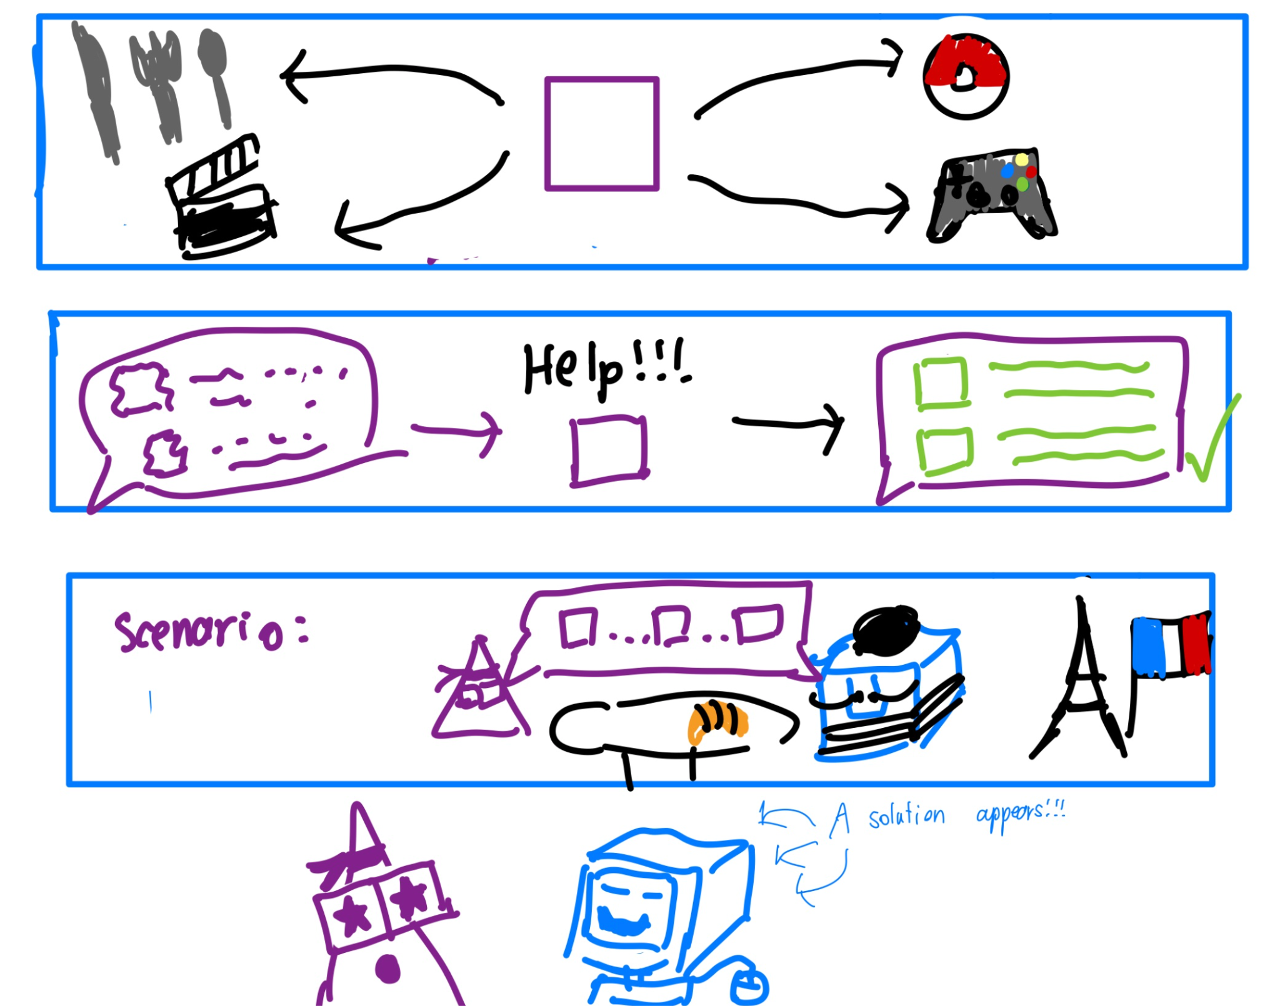

**Smart AI chat friend!**

Big T finds out about Smart AI Chat Friend!

Are you trying to learn a new language to talk to your grandma who does not know any English? Do you find it difficult, though you are a speaking expert and can understand what your grandma said 100%, you cannot order a single dish from the restaurant because you cannot read!? The Smart AI chat friend is here for you!

Specifically, it’s an all in 1 tool for language learning, for all learning levels.

It aims to:

1. Solve limited exposure by having the agent practice with you anytime, any place

2. Learn topics that actually interest you

1. Ask for suggestions on what to say when you are interested in a certain topic

3. Help confidence with practice: Practice conversation with the bot regarding those topics

4. Practice scenarios, such as ordering at a restaurant or asking for directions

5. Highlight to translate key terms, vocabulary, grammar points and save them for future study

# Happily Ever After!

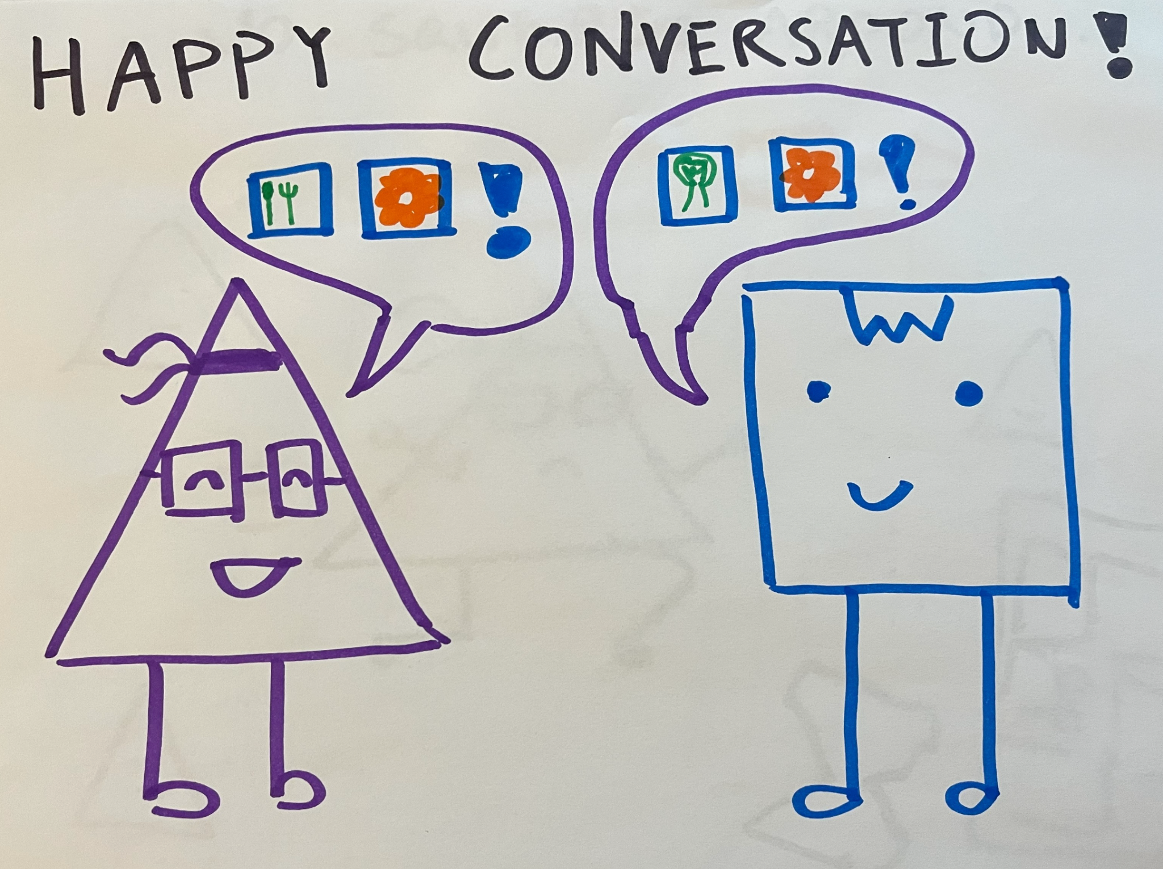

**Success!**

After practicing with his newfound tool, Big T is finally able to hold a meaningful and fun conversation with a square!